P.O Box 177
104 Main Street
Fillmore, NY 14735
Phone: (585) 567-2251
Fax: (585) 567-2541

FILLMORE CENTRAL SCHOOL

Dear Parent or Guardian:

We are pleased to introduce you to the PowerSchool Parent Portal. Parents and guardians can have one login to access all of their student’s grades and attendance in one place. Also, parents and guardians will not have to share logins as each parent or guardian can set up his or her own unique login and password. Please follow the directions below to get started using the PowerSchool Parent Portal. This system will replace the current parent/ guardian system for accessing PowerSchool.

- Go to the “PowerSchool Parent Portal” log in page:

https://fillmorecsd.powerschool.com/public/

- Choose Create Account
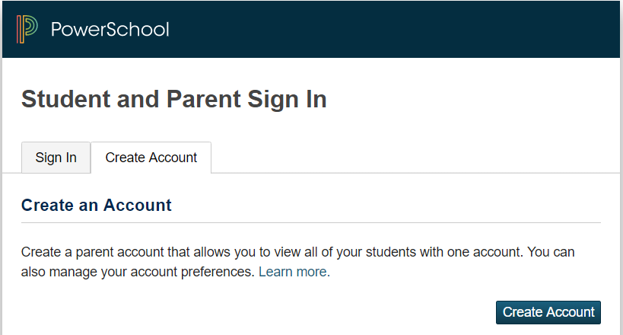

- At the top of the screen fill in your information including new password, which must be at least 6 characters.
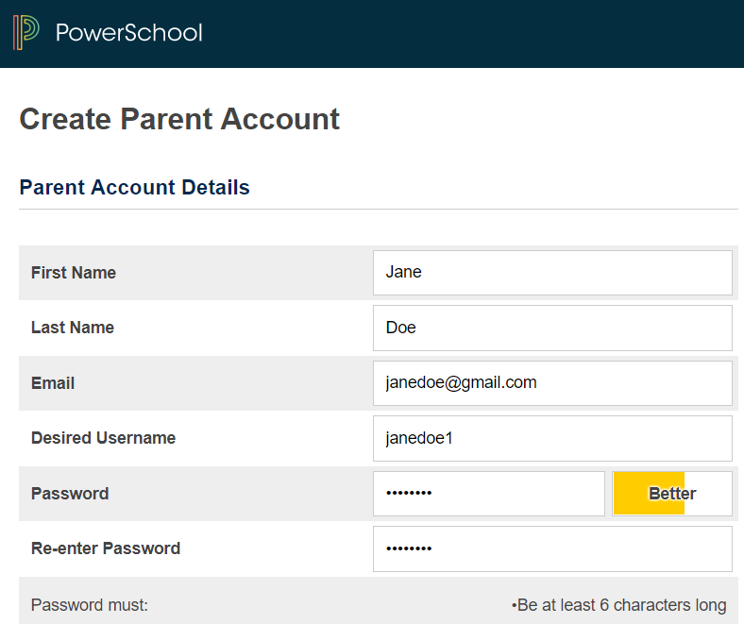

First Name – Enter your first name.
Last Name – Enter your last name.
Email – Enter your email address.
Desired User Name – Enter the user name you would like to use when logging into the PowerSchool Parent Portal. The user name must be unique. If you enter a user name that is already in use, you will be prompted to select or enter another user name.
Password – Must be a minimum of 6 characters. When entering your password a colored bar will appear to the right – this indicates the strength of the password.
Re-enter Password – Re-enter your password. The password you enter must match the Password field.

- At the bottom of the screen enter the Student Name, Access ID, Access Password (see below*), and choose a relationship to link your student(s) to your new login. If you have more than one student you can enter all of their names, Access IDs, and Access Passwords on this page. Once all information has been entered click enter.
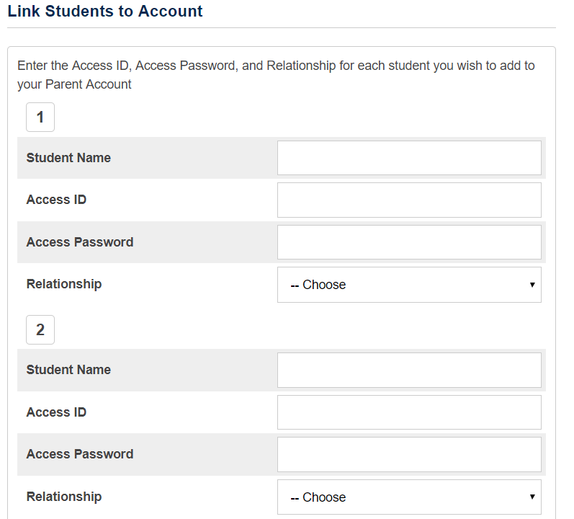

*Your Access ID and Access Password are the last 3-6 digits of each student’s identification number.

Example: Student ID 900456123 - Access ID and Password is 456123
**Please call an office for assistance with this step if you need help.**

Once you click enter you will be taken to the Parent Portal log in screen and should see the following:
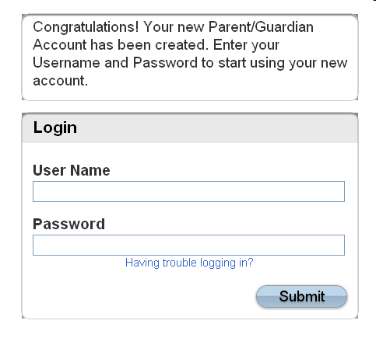

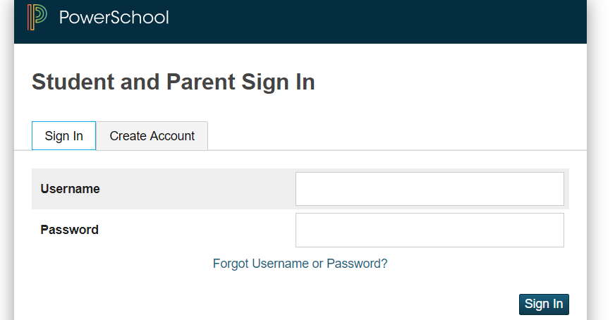

You will be sent an email with a link to click on to authenticate your account in the Parent Portal.
Once you are logged into the Parent Portal you can manage your account by clicking the Account Preferences button. If you have more than one student, you will see buttons to switch between your student’s information. Please note that you may have an email sent to you from PowerSchool that may require you to go to the email to click on the link to authenticate your account.

If you need help setting up your new account, please do not hesitate to contact me at 567-2289.

Sincerely,

Betsy Hardy
Director of Educational Technology

