STEM NOTEBOOK

*Force and Motion*

[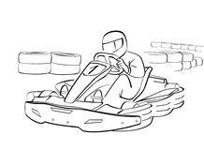](http://www.google.com/url?sa=i&rct=j&q=&esrc=s&source=images&cd=&cad=rja&uact=8&ved=0ahUKEwjrsZ-niYfMAhVBLB4KHRCPA0MQjRwIBw&url=http://www.dreamstime.com/royalty-free-stock-photography-go-kart-image5566537&bvm=bv.119028448,d.dmo&psig=AFQjCNEr3OOxYLYqOicCZEivhCBNpPpFYw&ust=1460480781917074)

Investigation 4: Representing Motion

BIG QUESTION: How can the motion of an object be represented as a graph?

What Do You See?

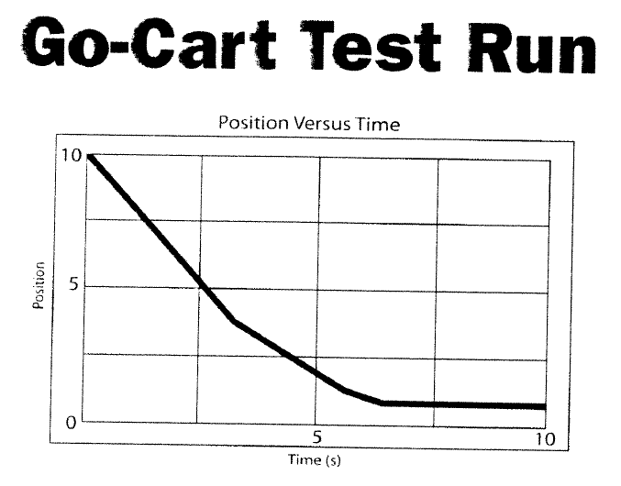

What Do You Think?

What Do You Think Now?

|  |
| --- |
| FOCUS QUESTION: How can your position at a given time be represented on a graph? |
| **SCENARIO: Leisurely Walk 1**   * **Start at home** * **Walk to the destination** * **Immediately walk back home** |
| DATA |
| EXPLANATION |

|  |
| --- |
| FOCUS QUESTION: How can your position at a given time be represented on a graph when we stop on the trip? |
| **SCENARIO: Leisurely Walk 2**   * **Start at home** * **Walk to the destination** * **Look at view for 15 seconds** * **Walk back home** |
| DATA |
| EXPLANATION |
| **SCENARIO: Leisurely Walk 3**   * **Start at home** * **Walk to the destination, turn, walk halfway home** * **Stop and rest 10 seconds** * **Complete the walk home** |
| DATA |
| EXPLANATION |

[](http://www.google.com/url?sa=i&rct=j&q=swap&source=images&cd=&cad=rja&docid=OJhLJ4prgzt77M&tbnid=1HNBxnz5cLqY9M:&ved=0CAUQjRw&url=http://www.derivativepricing.com/blog/bid/78048/Interest-Rate-Swap-Tutorial-Part-1-of-5-terminology&ei=564wUqLkAZLd4AOyxoDoCg&bvm=bv.52109249,d.dmg&psig=AFQjCNGxItKVcL3yUwb8uaeE8rMwptvz9Q&ust=1379008602678220)FACT SWAP[](http://www.google.com/url?sa=i&rct=j&q=swap&source=images&cd=&cad=rja&docid=OJhLJ4prgzt77M&tbnid=1HNBxnz5cLqY9M:&ved=0CAUQjRw&url=http://www.derivativepricing.com/blog/bid/78048/Interest-Rate-Swap-Tutorial-Part-1-of-5-terminology&ei=564wUqLkAZLd4AOyxoDoCg&bvm=bv.52109249,d.dmg&psig=AFQjCNGxItKVcL3yUwb8uaeE8rMwptvz9Q&ust=1379008602678220)

*Read Motion Review: Position and Motion sections only (pg 17-18)*

My Facts

|  |  |  |
| --- | --- | --- |
|  |  |  |

Facts from my Classmates

|  |  |  |
| --- | --- | --- |
|  |  |  |
|  |  |  |

WORD BANK: __________________________________________________________________________________________________________________________________________________________________________________________________________________________________________________________________________________________________________________________________________________________________________________________________________________

CONTENT: ________________________________________________________________________________________________________________________________________________________________________________________________________________________________________________________________________________________________________________________________________________________________________________________________________________________________________________________________________________

WDYTN

|  |
| --- |
| FOCUS QUESTION: How can distance travelled during a trip be represented on a graph? |
| **SCENARIO: Leisurely Walk 1**   * **Start at home** * **Walk to the destination** * **Immediately walk back home** |
| DATA |
| EXPLANATION |
| FOCUS QUESTION: How can distance travelled during a trip be represented on a graph when we stop during the trip? |
| **SCENARIO: Leisurely Walk 2**   * **Start at home** * **Walk to the destination** * **Look at view for 15 seconds** * **Walk back home** |
| DATA |
| EXPLANATION |
| **SCENARIO: Leisurely Walk 3**   * **Start at home** * **Walk to the destination, turn, walk halfway home** * **Stop and rest 10 seconds** * **Complete the walk home** |
| DATA |
| EXPLANATION |
| What Do You See?  (compare position graph and distance graph for each walk)  Walk #1:  Walk #2:  Walk #3: |
| EXPLANATION |

WORD BANK: __________________________________________________________________________________________________________________________________________________________________________________________________________________________________________________________________________________________________________________________________________________________________________________________________________________

CONTENT: ________________________________________________________________________________________________________________________________________________________________________________________________________________________________________________________________________________________________________________________________________________________________________________________________________________________________________________________________________________

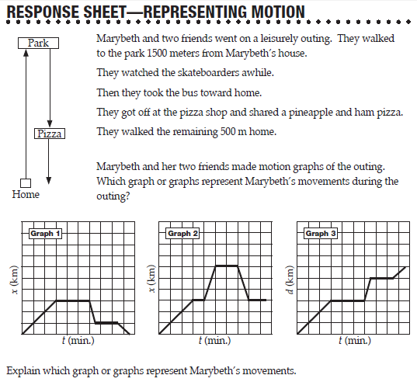

**POSTION, DISTANCE, TIME, SPEED SUMMARY**

CLANCEY’S AFTERNOON

* It took Clancey 10 minutes to ride his skateboard 2 kilometers down the hill to Richie’s house.
* They played Claw on the computer for 20 minutes.
* It took Clancey 20 minutes to walk back home up the hill.

Make a data table and two graphs to represent Clancey’s movement

|  |  |  |  |  |  |
| --- | --- | --- | --- | --- | --- |
| Leg | Time for leg | Total Time | Positionat end of leg | Distance during leg | Total Distance |
|  |  |  |  |  |  |
|  |  |  |  |  |  |
|  |  |  |  |  |  |
|  |  |  |  |  |  |

*Position Graph*

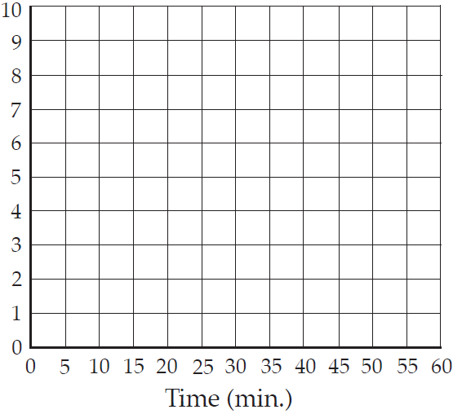

*Distance Graph*



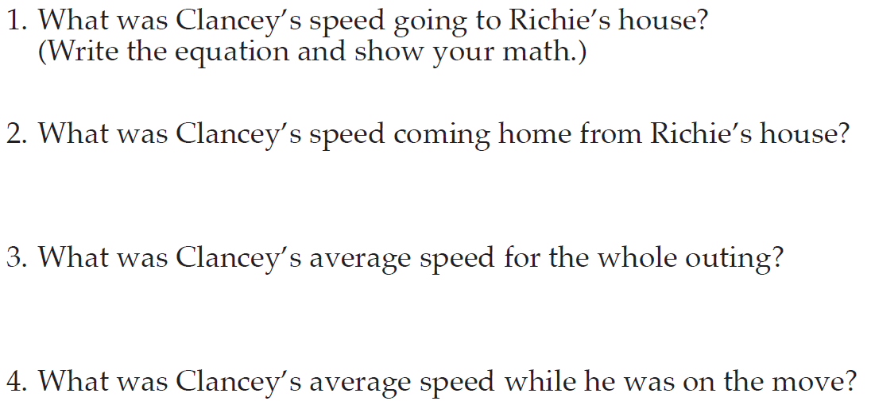

[](http://www.google.com/url?sa=i&rct=j&q=swap&source=images&cd=&cad=rja&docid=OJhLJ4prgzt77M&tbnid=1HNBxnz5cLqY9M:&ved=0CAUQjRw&url=http://www.derivativepricing.com/blog/bid/78048/Interest-Rate-Swap-Tutorial-Part-1-of-5-terminology&ei=564wUqLkAZLd4AOyxoDoCg&bvm=bv.52109249,d.dmg&psig=AFQjCNGxItKVcL3yUwb8uaeE8rMwptvz9Q&ust=1379008602678220)FACT SWAP[](http://www.google.com/url?sa=i&rct=j&q=swap&source=images&cd=&cad=rja&docid=OJhLJ4prgzt77M&tbnid=1HNBxnz5cLqY9M:&ved=0CAUQjRw&url=http://www.derivativepricing.com/blog/bid/78048/Interest-Rate-Swap-Tutorial-Part-1-of-5-terminology&ei=564wUqLkAZLd4AOyxoDoCg&bvm=bv.52109249,d.dmg&psig=AFQjCNGxItKVcL3yUwb8uaeE8rMwptvz9Q&ust=1379008602678220)

*Read Motion Review: Speed section (pg 18-19)*

My Facts

|  |  |  |
| --- | --- | --- |
|  |  |  |

Facts from my Classmates

|  |  |  |
| --- | --- | --- |
|  |  |  |
|  |  |  |

WORD BANK: __________________________________________________________________________________________________________________________________________________________________________________________________________________________________________________________________________________________________________________________________________________________________________________________________________________

CONTENT: ________________________________________________________________________________________________________________________________________________________________________________________________________________________________________________________________________________________________________________________________________________________________________________________________________________________________________________________________________________

|  |  |
| --- | --- |
| BIG QUESTION: How can the motion of an object be represented as a graph? | |
| CLAIM STATEMENTS: | SUPPORTING EVIDENCE: |