STEM NOTEBOOK

*Earth’s Resources*

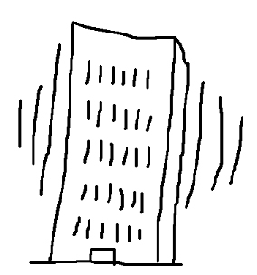



Investigation 4: Our Dynamic Planet

BIG QUESTION: What factors must be considered when constructing a three-story building that will withstand the movement of an earthquake?

|  |
| --- |
| What Do You See? |
| What Do You Think? |
| What Do You Think Now? |

**ENGINEERING CHALLENGE**

**Scenario:** You have been hired as a geologist to consult with the architectural design firm that is designing a new office building in an earthquake prone city. The building must be three-stories high and able to withstand an earthquake. (GOAL)

**What do you want to know before you begin?**

**How will we measure success?**

|  |
| --- |
| FOCUS QUESTION: What are lithospheric plates and what happens when these plates meet? |
| PREDICTION |
| OBSERVATIONS/SKETCH |
| DATA/MEASUREMENTS |
| EXPLANATION  Tectonic plates |

|  |
| --- |
| FOCUS QUESTION: How has the Earth changed over time? |
| OBSERVATIONS |
|  |

WORD BANK: _____________________________________________________________________________________________________________________________________________________________________________________________________________________________________________________________________________________________________________________________________________________________________________________________________________________________________________________________________________________

CONTENT: ________________________________________________________________________________________________________________________________________________________________________________________________________________________________________________________________________________________________________________________________________________________________________________________________________________________________________________________________________________

ENGINEERING CHALLENGE

Is there anything else you would like to know before you begin?

|  |
| --- |
| Why do you think your design will be successful? |
| Cost of your design |
| After testing your design, and viewing the design of others, are there any modifications you would make to your design? |

|  |  |
| --- | --- |
| BIG QUESTION: What factors must be considered when constructing a three-story building that will withstand the movement of an earthquake? | |
| CLAIM STATEMENTS: | SUPPORTING EVIDENCE: |