STEM NOTEBOOK

*Force and Motion*

[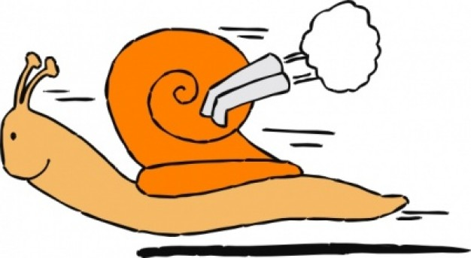](http://www.clipartpanda.com/clipart_images/high-speed-clip-art-with-8888756)

Investigation 2 & 3: Speed

BIG QUESTION: How can the speed of an object be described?

What Do You See?

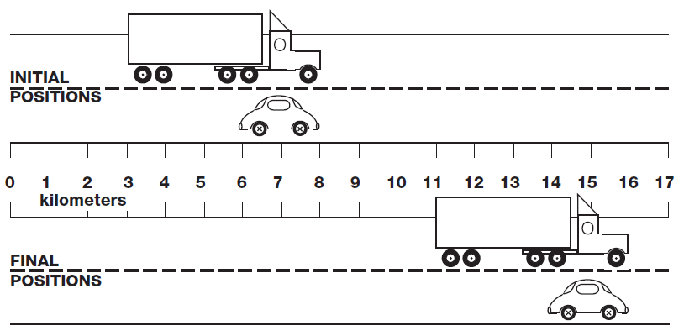

What Do You Think?

What Do You Think Now?

|  |
| --- |
| FOCUS QUESTION: How are speed, distance, and time related? |
| **WHO GOT THERE FIRST?**   |  |  | | --- | --- | | ***Race 1*** | | | Claim | Evidence | | ***Race 2*** | | | Claim | Evidence | | ***Race 3*** | | | Claim | Evidence | |
| EXPLANATION |
| **SUMMARY GRAPHIC ORGANIZER** |
| *Title: _______________________________________________* |
| Main Idea |
| What are the 3 most important words in the Main Idea, and write them here:  ________________________, _______________________, ________________________ |
| Three Important Details   1. _______________________________________________________________________ 2. _______________________________________________________________________ 3. _______________________________________________________________________ |
| Summary of the Passage in ONE Sentence |

WORD BANK: __________________________________________________________________________________________________________________________________________________________________________________________________________________________________________________________________________________________________________________________________________________________________________________________________________________

CONTENT: ________________________________________________________________________________________________________________________________________________________________________________________________________________________________________________________________________________________________________________________________________________________________________________________________________________________________________________________________________________

WDYTN

|  |
| --- |
| FOCUS QUESTION: How can speed, distance, and time be represented mathematically? |
| **TIME TRAVEL** |
| FOCUS QUESTION: How can a ramp and car system be used to calculate the speed an object travels? |
| PLAN |
| DATA |
| CLASS DATA |
| GRAPH |
| EXPLANATION |

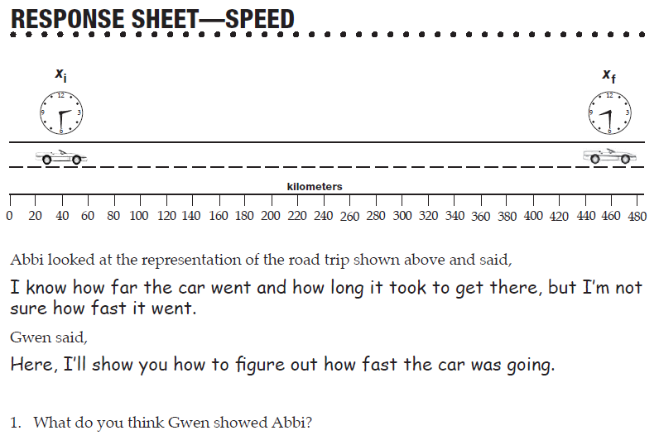

READ: *First in Flight*

[](http://www.google.com/url?sa=i&rct=j&q=swap&source=images&cd=&cad=rja&docid=OJhLJ4prgzt77M&tbnid=1HNBxnz5cLqY9M:&ved=0CAUQjRw&url=http://www.derivativepricing.com/blog/bid/78048/Interest-Rate-Swap-Tutorial-Part-1-of-5-terminology&ei=564wUqLkAZLd4AOyxoDoCg&bvm=bv.52109249,d.dmg&psig=AFQjCNGxItKVcL3yUwb8uaeE8rMwptvz9Q&ust=1379008602678220)FACT SWAP [](http://www.google.com/url?sa=i&rct=j&q=swap&source=images&cd=&cad=rja&docid=OJhLJ4prgzt77M&tbnid=1HNBxnz5cLqY9M:&ved=0CAUQjRw&url=http://www.derivativepricing.com/blog/bid/78048/Interest-Rate-Swap-Tutorial-Part-1-of-5-terminology&ei=564wUqLkAZLd4AOyxoDoCg&bvm=bv.52109249,d.dmg&psig=AFQjCNGxItKVcL3yUwb8uaeE8rMwptvz9Q&ust=1379008602678220)

My Facts

|  |  |  |
| --- | --- | --- |
|  |  |  |

Facts from my Classmates

|  |  |  |
| --- | --- | --- |
|  |  |  |
|  |  |  |

WORD BANK: __________________________________________________________________________________________________________________________________________________________________________________________________________________________________________________________________________________________________________________________________________________________________________________________________________________

CONTENT: ________________________________________________________________________________________________________________________________________________________________________________________________________________________________________________________________________________________________________________________________________________________________________________________________________________________________________________________________________________

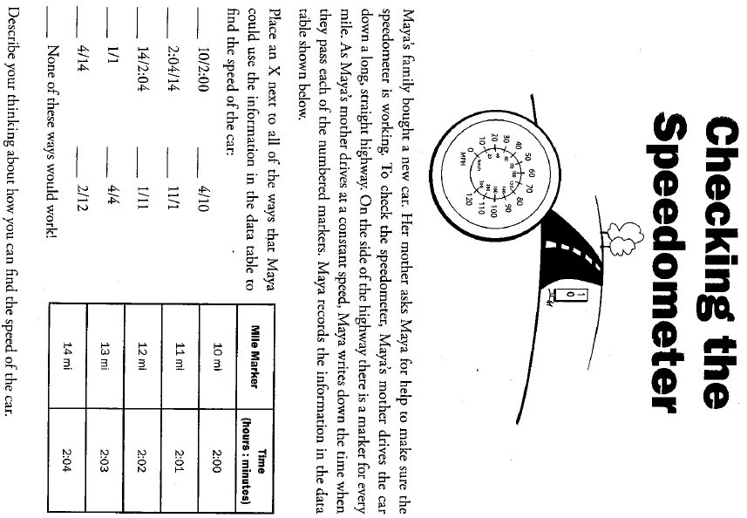

|  |
| --- |
| FOCUS QUESTION: How can walking and running speed be compared? |
| PLAN |
| DATA |
| CLASS DATA |
| GRAPH |
| EXPLANATION |
| FOCUS QUESTION: How can slope of a graph be used to compare speeds of different objects? (multimedia) |
| GRAPH |
| EXPLANATION |

Read: *How Fast Do Things Go?*

READERS SHOW THEIR THINKING

|  |  |  |
| --- | --- | --- |
| ! | Surprising Part |  |
| * | Important Part |  |
|  | Favorite Part |  |
| ? | Confusing Part |  |
| W | Wonder Part |  |

WORD BANK: __________________________________________________________________________________________________________________________________________________________________________________________________________________________________________________________________________________________________________________________________________________________________________________________________________________

CONTENT: ________________________________________________________________________________________________________________________________________________________________________________________________________________________________________________________________________________________________________________________________________________________________________________________________________________________________________________________________________________

|  |  |
| --- | --- |
| BIG QUESTION: How can the speed of an object be described? | |
| CLAIM STATEMENTS: | SUPPORTING EVIDENCE: |