No Bake Chocolate Oatmeal Cookies

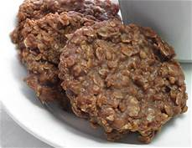

Ingredients

¼ cup butter

1 cup sugar

¼ cup milk

2 Tbsp cocoa

¼ cup creamy peanut butter

1 tsp vanilla

1 ½ cups oats

Directions:

1. Add the first four ingredients into a 4 quart sauce pan
2. Bring to a rolling boil and hold at the boil for approx one minute
3. Remove from heat
4. Add peanut butter into the hot mixture and stir until melted
5. Add in vanilla
6. Mix in the oats and drop on a Tablespoon onto the wax paper
7. Let cool until set

Make sure you area is clean and all of your dishes are done before you eat!