STEM Notebook

*Force and Motion*

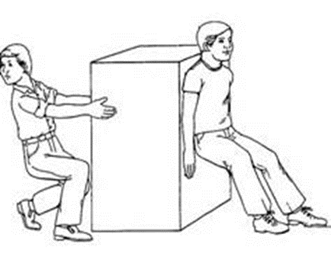

Investigation: 6/7 Forces

BIG QUESTION: What is the effect of forces acting on an object and how do we measure and describe them?

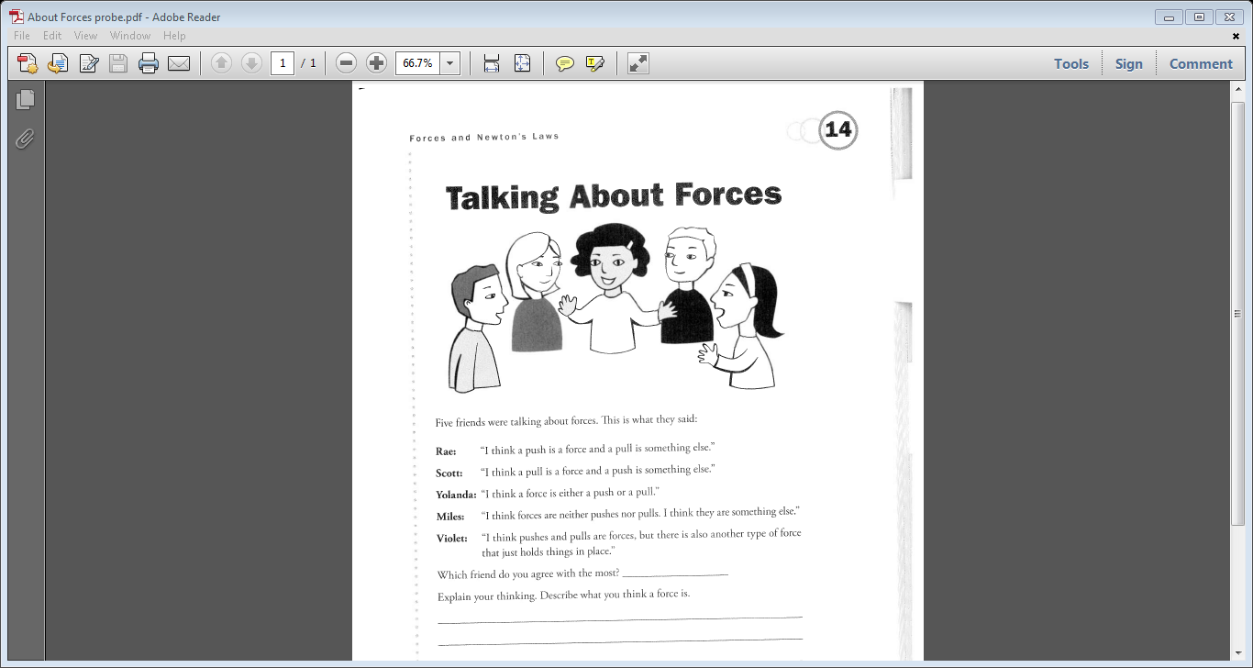

|  |
| --- |
| FOCUS QUESTION: What interactions cause the movement of an object? |
| Part 1: Pusher System  Make a sketch of your pusher system. |
| Describe the importance of the parts of a pusher system and how they make the tool work. |
| What can you measure with the pusher system? How do you compare the “pushes” to move one object versus another? What do you notice as you “push?” |
| Part 2: Puller System  Make a sketch of your puller system. |
| What can you measure with the puller system? How do you compare the “pulls” to move one object versus another? What do you notice as you “pull?” |
| EXPLANATION |

|  |
| --- |
| FOCUS QUESTION: What is the relationship between mass and the force needed to slide it across a surface? |
| DATA |
| What Do You See? |
| Claim/Evidence |
| APPLICATION |
| EXTENSION |

WORD BANK/CONTENT

_________________________________________________________________________________________________________________________________________________________________________________________________________________________________________________________________________________________________________________________________________________________________________________________________________________________________________________________________________________________________________________________________________________________________________________________________________________________________________________________________________________________________________________________________________________________________________________________________________________________________________________________________________________________________________________________________________________________________________________________________________________________________________________________________________________________________________________________________________________________________________________________________________________________________________________________________________________________________________________________________________________________________________________________________________________________________________________________________________________________________________________________________________________________________________________________________________________________________________________________________________________________________________________________________________________________________________________________________________________________________________________________WDYTN- Force

RESPONSE SHEET

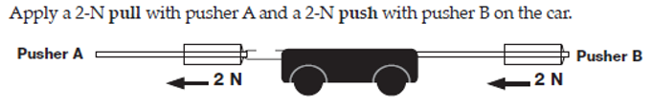

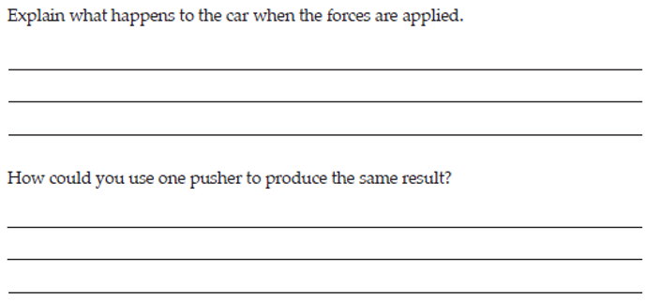

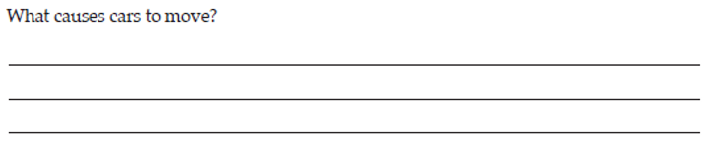

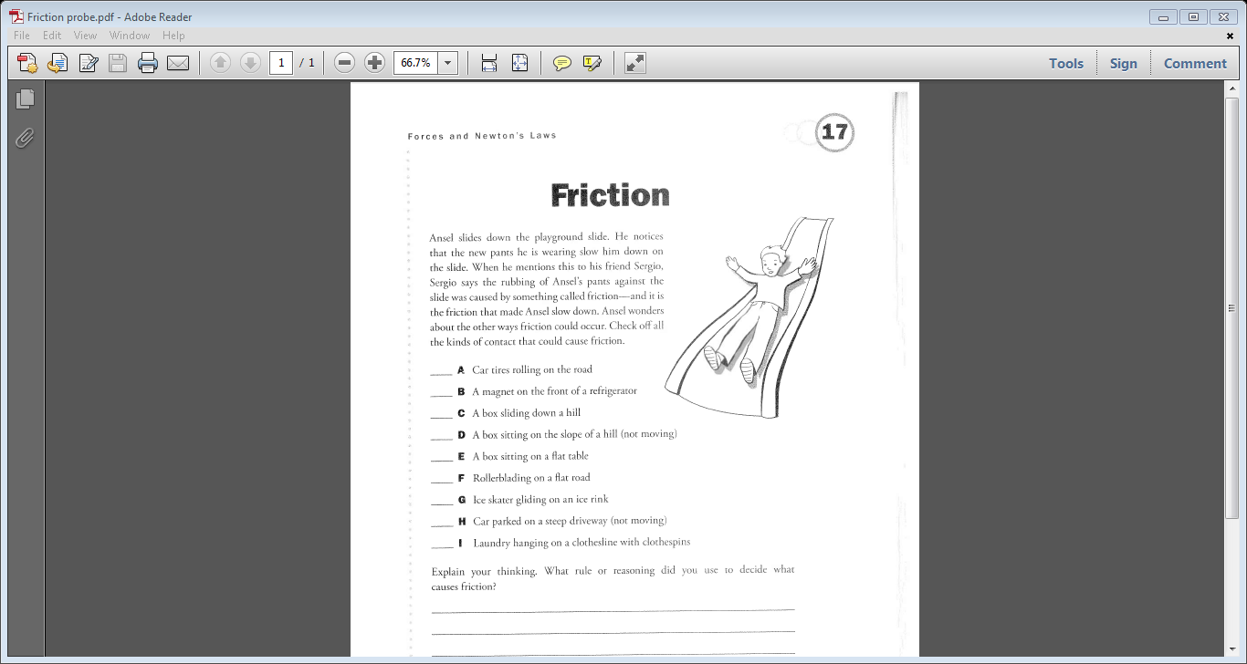

|  |
| --- |
| FOCUS QUESTION: What factors influence the motion of an object besides its mass and the force you are applying to make it move? |
| Prediction |
| Sketch the pulley and sled setup for this experiment |
| DATA A |
| What Do You See? |
| What Do You Think?  (What is hindering the motion? How could we reduce it?) |
| DATA B |
| What Do You Think Now? |
| EXPLANATION |

|  |
| --- |
| FOCUS QUESTION: What is net force? |
| DATA |
| APPLICATION |
| EXTENSION |
| EXPLANATION |
| Claim/Evidence |

WORD BANK/CONTENT

_________________________________________________________________________________________________________________________________________________________________________________________________________________________________________________________________________________________________________________________________________________________________________________________________________________________________________________________________________________________________________________________________________________________________________________________________________________________________________________________________________________________________________________________________________________________________________________________________________________________________________________________________________________________________________________________________________________________________________________________________________________________________________________________________________________________________________________________________________________________________________________________________________________________________________________________________________________________________________________________________________________________________________________________________________________________________________________________________________________________________________________________________________________________________________________________________________________________________________________________________________________________________________________________________________________________________________________________________________________________________________________________WDYTN- Friction

RESPONSE SHEET

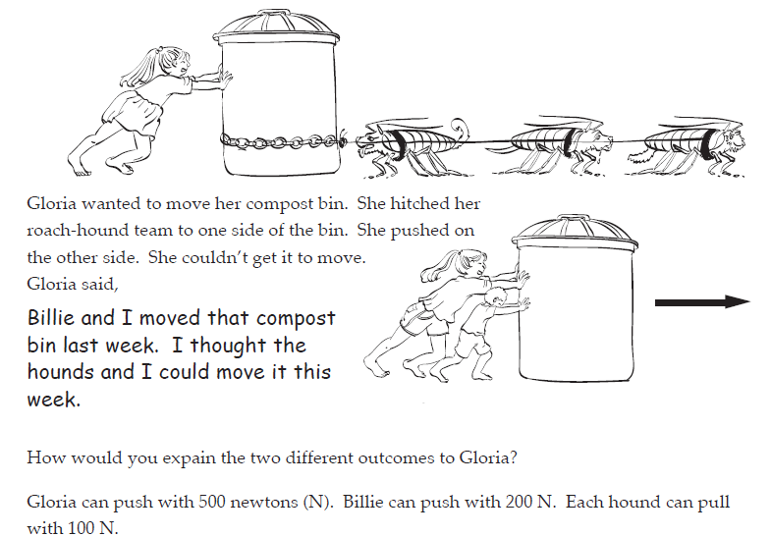

PRE-READ

Paulette and Becky were disagreeing over who had the greatest impact on Physics before Sir Isaac Newton.

Paulette said, “Everyone knows that if something isn’t moving there are no forces acting on it – it is naturally still, just like Aristotle said. He’s the greatest one.”

Unmoved, Becky proclaimed, “Galileo was the greatest. I think he recognized that it is a balance of forces which causes something to be STILL, not the absence of forces! Friction is one of the forces acting on something which is still.”

What do you think? Explain who you agree with and why.

**READ**

***Aristotle, Galileo & Newton (pg 50)***

POST-READ

What do you think now about what the girls were saying?

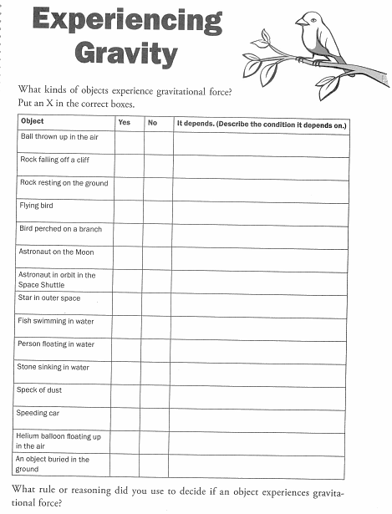

|  |
| --- |
| FOCUS QUESTION: What is the relationship between the force of gravity and mass? |
| PLAN: |
| OBSERVATIONS |
| Claim/Evidence |

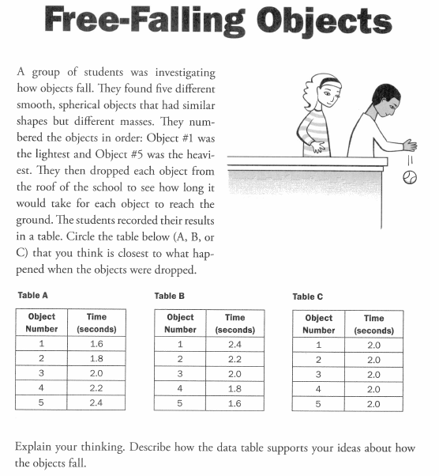

|  |
| --- |
| FOCUS QUESTION: Does the mass of an object impact how ***FAST*** it falls? |
| OBSERVATIONS: |
| EXPLANATION |
| What other factors may impact a “fall?” |

WORD BANK/CONTENT

_________________________________________________________________________________________________________________________________________________________________________________________________________________________________________________________________________________________________________________________________________________________________________________________________________________________________________________________________________________________________________________________________________________________________________________________________________________________________________________________________________________________________________________________________________________________________________________________________________________________________________________________________________________________________________________________________________________________________________________________________________________________________________________________________________________________________________________________________________________________________________________________________________________________________________________________________________________________________________________________________________________________________________________________________________________________________________________________________________________________________________________________________________________________________________________________________________________________________________________________________________________________________________________________________________________________________________________________________________________________________________________________WDYTN- Free Falling Objects

[](http://www.google.com/url?sa=i&rct=j&q=swap&source=images&cd=&cad=rja&docid=OJhLJ4prgzt77M&tbnid=1HNBxnz5cLqY9M:&ved=0CAUQjRw&url=http://www.derivativepricing.com/blog/bid/78048/Interest-Rate-Swap-Tutorial-Part-1-of-5-terminology&ei=564wUqLkAZLd4AOyxoDoCg&bvm=bv.52109249,d.dmg&psig=AFQjCNGxItKVcL3yUwb8uaeE8rMwptvz9Q&ust=1379008602678220)FACT SWAP[](http://www.google.com/url?sa=i&rct=j&q=swap&source=images&cd=&cad=rja&docid=OJhLJ4prgzt77M&tbnid=1HNBxnz5cLqY9M:&ved=0CAUQjRw&url=http://www.derivativepricing.com/blog/bid/78048/Interest-Rate-Swap-Tutorial-Part-1-of-5-terminology&ei=564wUqLkAZLd4AOyxoDoCg&bvm=bv.52109249,d.dmg&psig=AFQjCNGxItKVcL3yUwb8uaeE8rMwptvz9Q&ust=1379008602678220)

*Read: How to Get and Hold On To a Moon (pg 67)*

My Facts

|  |  |  |
| --- | --- | --- |
|  |  |  |

Facts from my Classmates

|  |  |  |
| --- | --- | --- |
|  |  |  |
|  |  |  |

|  |  |
| --- | --- |
| BIG QUESTION: What is the effect of forces acting on an object and how do we measure and describe them? | |
| CLAIM STATEMENTS | SUPPORTING EVIDENCE |