**ANNIE’s FRUIT SALSA AND CINNAMON CHIPS**

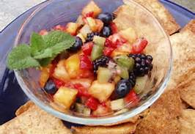

**Ingredients:**

|  |  |
| --- | --- |
| Bunch of Green grapes  2 Golden Delicious apples -  peeled, cored and diced  1/2 pound strawberries  1 tablespoons white sugar  1/2 tablespoon brown sugar | 2 tablespoons fruit preserves,  5 (10 inch) flour tortillas  butter flavored cooking spray  1 tablespoons cinnamon sugar |

**Directions:**

Group 1:

1. Preheat oven to 350
2. Coat one side of each flour tortilla with cooking spray.
3. Cut into wedges and arrange on a single layer on a large baking sheet. Sprinkle wedges with the cinnamon sugar. Spray again with cooking spray.
4. Bake in a preheated oven 8 to 10 minutes.

Group 2:

1. Wash grapes, cut them in half
2. Peel, core and dice apples
3. Wash and cut strawberries in pieces, small as desired
4. Put fruit in a mixing bowl
5. Mix in sugar, brown sugar and fruit preserves

Make sure your area is all cleaned up before you start eating!!!!!!!