STEM NOTEBOOK

*Force and Motion*

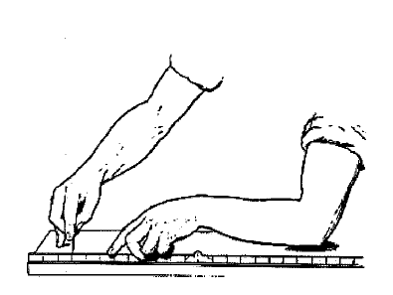

Investigation 1: Here to There

BIG QUESTION: How can the motion of an object be modeled and described?

What Do You See?

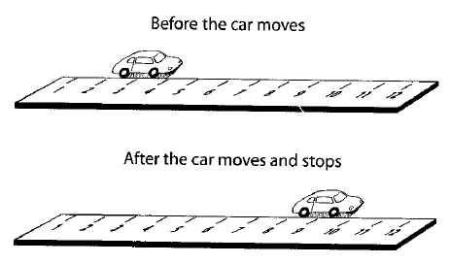

What Do You Think?

What Do You Think Now?

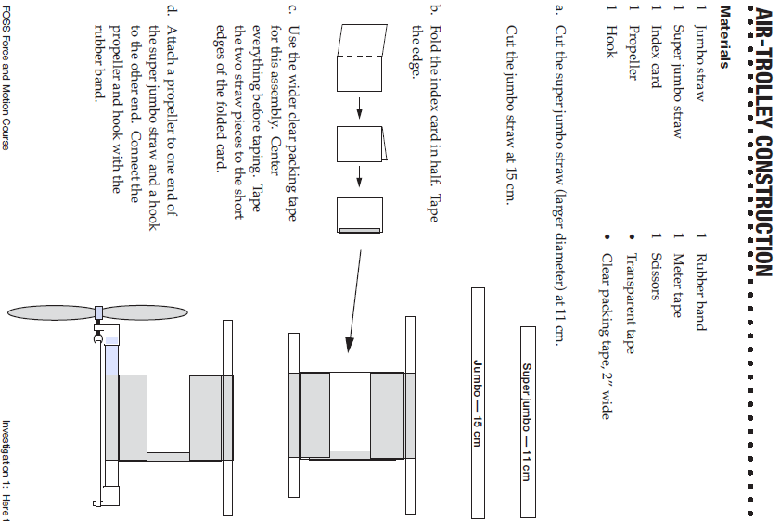

|  |  |
| --- | --- |
| FOCUS QUESTION: How can an air trolley be used to observe motion? | |
| OBSERVATIONS | |
| PLAN | DATA |
| CLASS DATA | |
| GRAPH | |
| EXPLANATION | |

WORD BANK: __________________________________________________________________________________________________________________________________________________________________________________________________________________________________________________________________________________________________________________________________________________________________________________________________________________

CONTENT: ______________________________________________________________________________________________________________________________________________________________________________________________________________________________________________________________________________________________________________________________________________________________________________________________________________________Card Sort/Multimedia- Moving Along

WDYTN

RESPONSE SHEET- ROAD RACES

Using your Road Race scenario, complete the information below. Be sure to use the distance formula and show all of your math.

ROAD RACE # _____

SCENARIO:

|  |  |  |  |
| --- | --- | --- | --- |
| vehicle | Xf | Xi | distance |
|  |  |  |  |
|  |  |  |  |
|  |  |  |  |

Which vehicle went the shortest distance?

|  |  |
| --- | --- |
| CLAIM | EVIDENCE |

Which vehicle went the farthest?

|  |  |
| --- | --- |
| CLAIM | EVIDENCE |

How much farther?

|  |  |
| --- | --- |
| CLAIM | EVIDENCE |

|  |  |
| --- | --- |
| BIG QUESTION: How can the motion of an object be modeled and described? | |
| CLAIM STATEMENTS: | SUPPORTING EVIDENCE: |